**EXPNO 2:**

**DATE:09-02-2023**

**CREATE A VIRTUAL MACHINE WITH 1 VCPU, 2GB RAM AND 15GB STORAGE DISK USING A TYPE 2 VIRTUALIZATION SOFTWARE**

**AIM**: Tocreate a virtual machine with 1 CPU, 2gb ram and 15gb storage disk using a type 2 virtualization software

**PROCEDURE:**

1. Download VMware workstation and installed as type 2 hypervisor
2. Download Ubuntu or tiny os as iso image file
3. In VMware workstation->create new VM
4. Do the basic configuration settings.
5. Created tiny OS virtual machine
6. Launch the VM

**IMPLEMENTATION:**

**STEP 1:**

**DOWLOAD VMWARE WORKSTATION AND INSTALLED AS TYPE 2 HYPERVISOR**

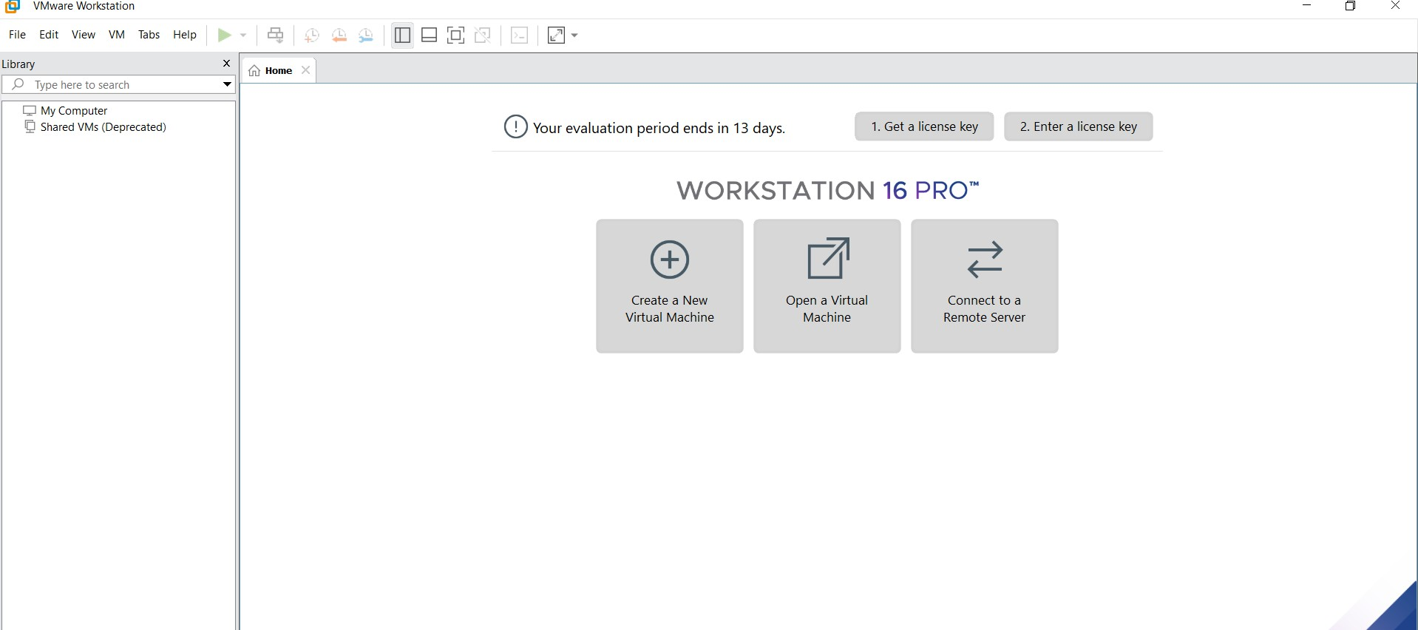

**STEP2: DOWLOAD UBUNTU OR TINY OS AS ISO IMAGE FILE**

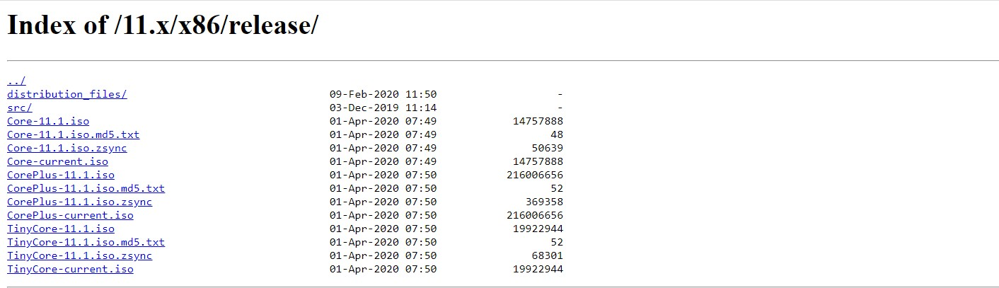

**STEP 3: IN VMWARE WORKSTATION->CREATE NEW VM**



**STEP 4: DO THE BASIC CONFIGURATION SETTINGS.**

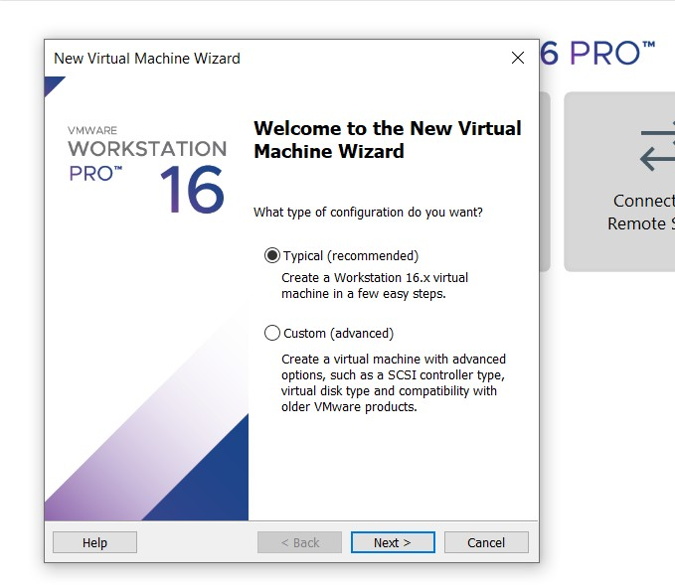

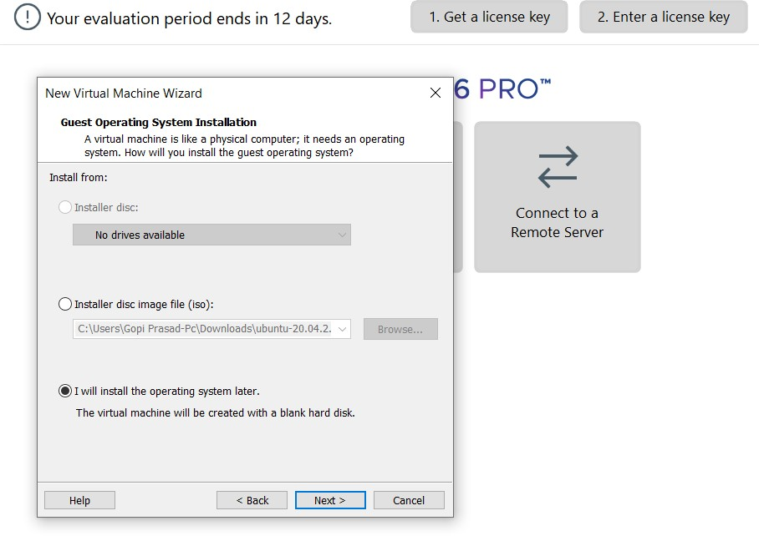

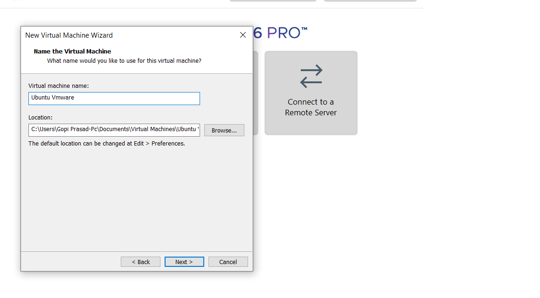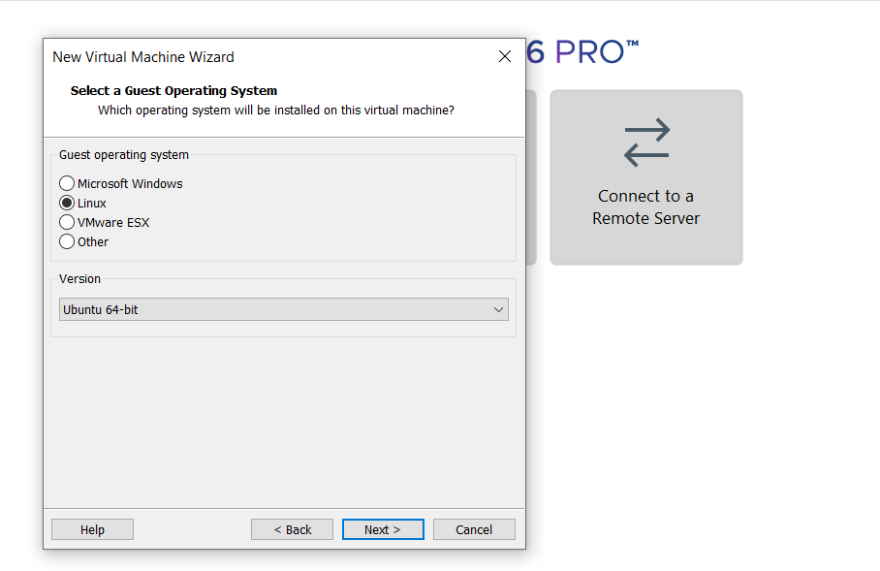

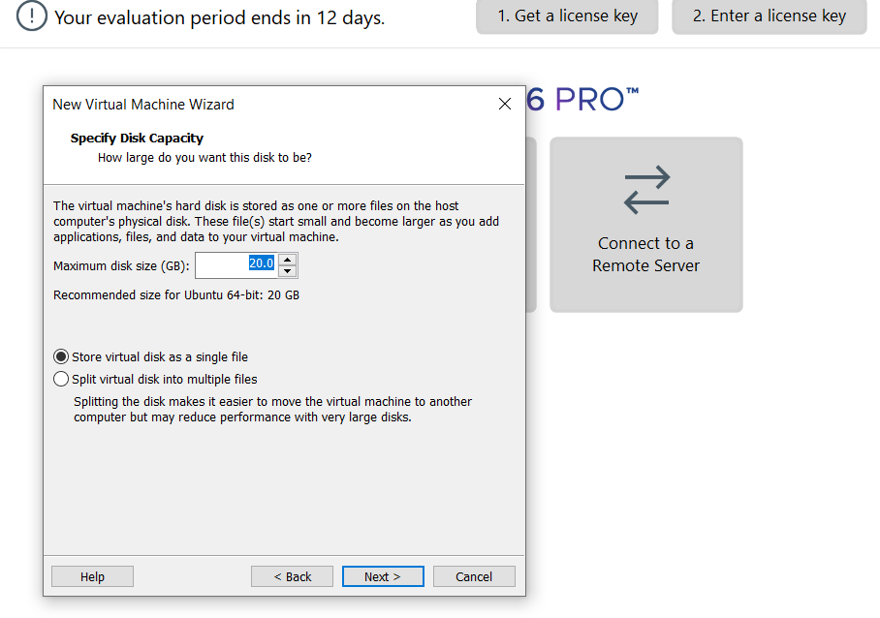



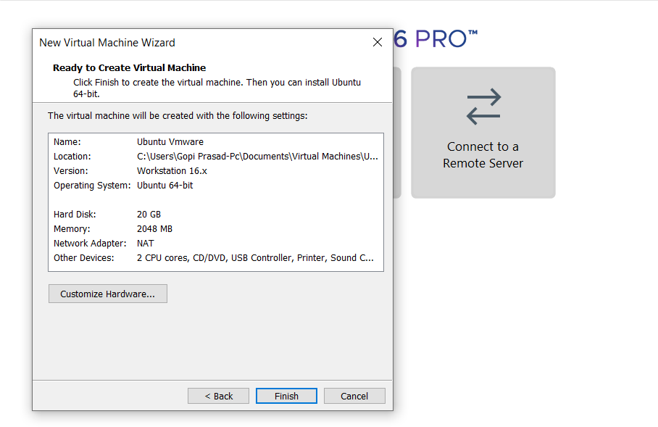

**STEP 4: CREATED TINYOS VIRTUAL MACHINE**

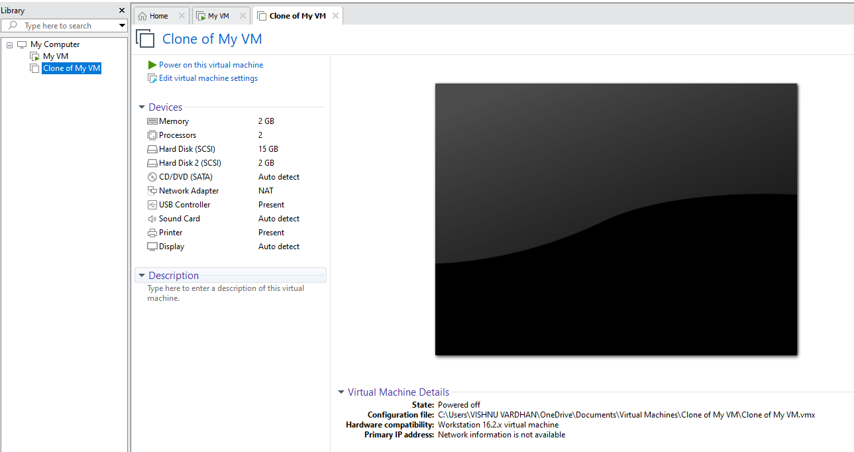

**STEP 5: LAUNCH THE VM**

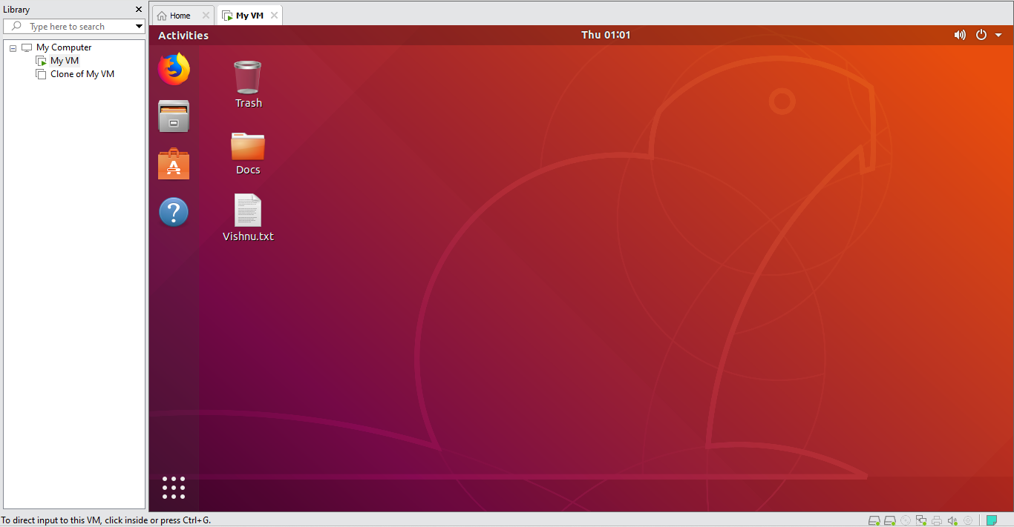

**RESULT:**

Hence created a virtual machine with 1 CPU, 2gb ram and 15gb storage disk using a type 2 virtualization software.